a2A4200-12gmBAS
The a2A4200-12gmBAS Basler ace 2 R camera is equipped with a Gpixel GMAX2509 sensor.
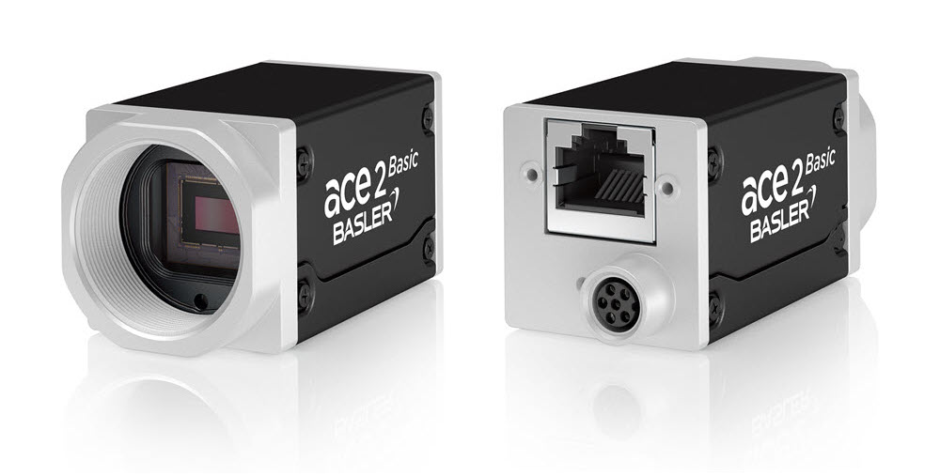
Specifications
General Specifications
 | a2A4200-12gmBAS
Resolution (H x V Pixels) | 4200 x 2160 (full resolution)  4200 x 2128 (default resolution)
Resolution | 9 MP
Sensor Type | GMAX2509  Progressive scan CMOS  Global shutter
Sensor Format | 2/3"
Effective Sensor Diagonal | 11.81 mm
Pixel Size (H x V) | 2.5 x 2.5 µm
Frame Rate (at Default Settings) | 11.5 fps  13.0 fps (with Bandwidth Reserve mode set to Performance and packet size set to 4000)
Product Family | ace 2 R
Mono / Color | Mono
Image Data Interface | Fast Ethernet (100 Mbit/s)  Gigabit Ethernet (1000 Mbit/s)
Pixel Formats | See Pixel Format.
Synchronization | Via hardware trigger  Via software trigger  Via free run
Exposure Time Control | Via hardware trigger  Programmable via the camera API
Camera Power Requirements | ≈4.5 W (typical) when using Power over Ethernet  ≈3.4 W (typical) @ 12–24 VDC when supplied via I/O connector
I/O Lines | 1 opto-coupled input line  2 general purpose I/O (GPIO) lines
Lens Mount | C-mount
Size (L x W x H) | 48.9 x 29 x 29 mm (without lens mount or connectors)  62.2 x 29 x 29 mm (with lens mount and connectors)
Weight | <100 g
Conformity | CE (includes RoHS), EAC, UL Listed, FCC, KC, GenICam, GigE Vision, IP30, IEEE 802.3af (PoE)  Certificates for your camera model  For more information, see the Compliance section of the Basler website.
Software | Basler pylon Software Suite (version 6.0 or higher)  Available for Windows, Linux x86, Linux ARM, macOS, and Android
Accessories | Lenses –  C125-0418-5M-P f4mm 2000034830  C125-0618-5M-P f6mm 2000034831  C125-0818-5M-P f8mm 2000034832  C125-1218-5M-P f12mm 2000034833  C125-1620-5M-P f16mm 2000034834  C125-2522-5M-P f25mm 2000034835

Cables –
GigE Cable - with screwlock 2200000622
M8, 5m, axial - Lighting Cable 2200000899

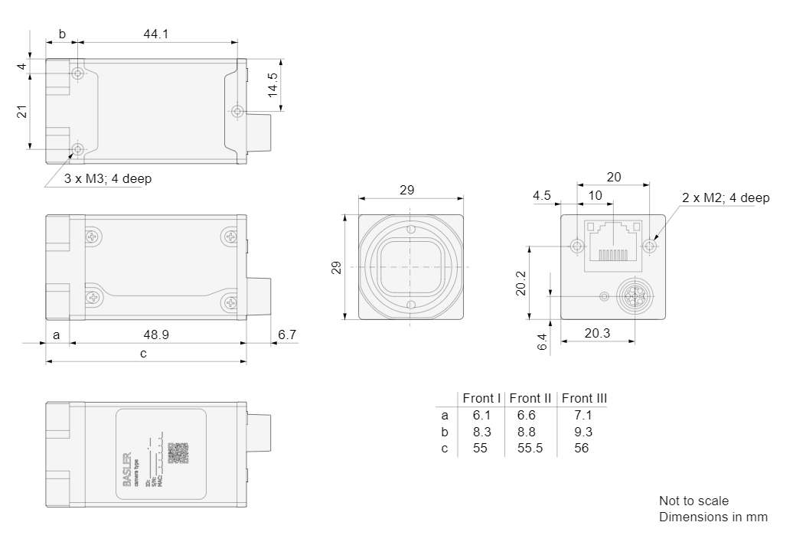
Drawing –
Please contact OEM Automatic for technical assistance.
Email: vision@oem.co.uk
Telephone: 01162849900

