a2A3840-45umBAS
The a2A3840-45umBAS Basler ace 2 R camera is equipped with a Sony IMX334 sensor.
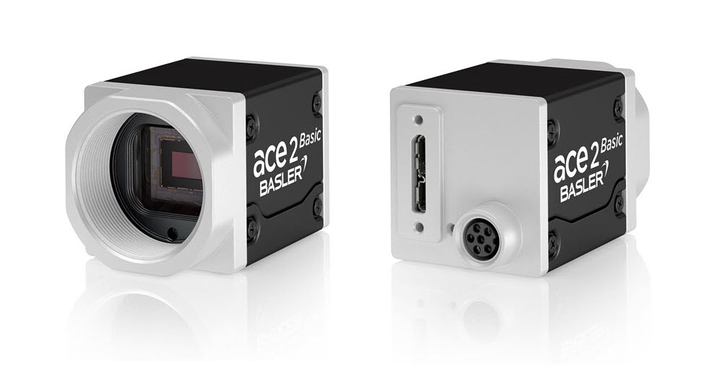
Specifications
General Specifications
 | a2A3840-45umBAS
Resolution (H x V Pixels) | 3860 x 2178 (full resolution)  3840 x 2160 (default resolution)
Resolution | 8.3 MP
Sensor Type | Sony IMX334LLR-C  Progressive scan CMOS  Rolling shutter
Sensor Format | 1/1.8"
Effective Sensor Diagonal | 8.86 mm
Pixel Size (H x V) | 2.0 x 2.0 µm
Frame Rate (at Default Settings) | 43.3 fps  45.7 fps (Device Link Throughput Limit mode set to Off)  24.3 fps (with triggering via Frame Start trigger)
Product Family | ace 2 R
Mono / Color | Mono
Image Data Interface | USB 3.0, nominal max. 5 Gbit/s (SuperSpeed)
Pixel Formats | See Pixel Format.
Synchronization | Via hardware trigger  Via software trigger  Via free run
Exposure Time Control | Programmable via the camera API
Camera Power Requirements | ≈2.5 W (typical) @ 5 VDC
I/O Lines | 1 opto-coupled input line  2 general purpose I/O (GPIO) lines
Lens Mount | C-mount
Size (L x W x H) | 36.3 x 29 x 29 mm (without lens mount or connectors)  48.1 x 29 x 29 mm (with lens mount and connectors)
Weight | <85 g
Conformity | CE (includes RoHS), EAC, UL Listed, FCC, KC, GenICam, USB3 Vision, IP30  Certificates for your camera model  For more information, see the Compliance section of the Basler website.
Software | Basler pylon Software Suite (version 6.0 or higher)  Available for Windows, Linux x86, Linux ARM, macOS, and Android
Accessories | Lenses –  C125-0418-5M-P f4mm 2000034830  C125-0618-5M-P f6mm 2000034831  C125-0818-5M-P f8mm 2000034832  C125-1218-5M-P f12mm 2000034833  C125-1620-5M-P f16mm 2000034834  C125-2522-5M-P f25mm 2000034835  Cables –  USB Cable - with screwlock 2200000620  USB Cable - with screwlock 2200000621  USB Cable - without screwlock 2000035131  USB Cable - without screwlock 2000035315  M8, 5m, axial - Lighting Cable 2200000899
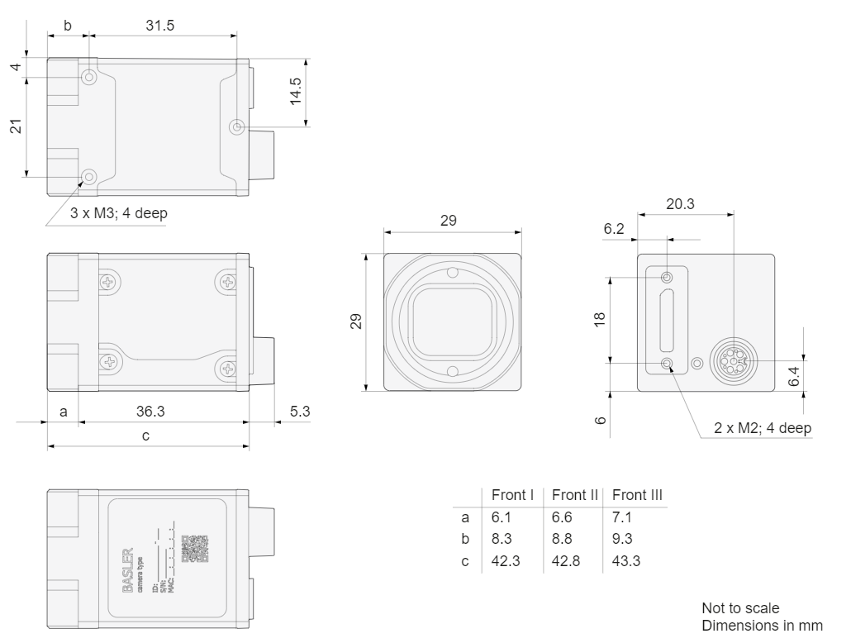
Drawing –


