**a2A3840-45ucBAS**

The a2A3840-45ucBAS Basler ace 2 R camera is equipped with a Sony IMX334 sensor.

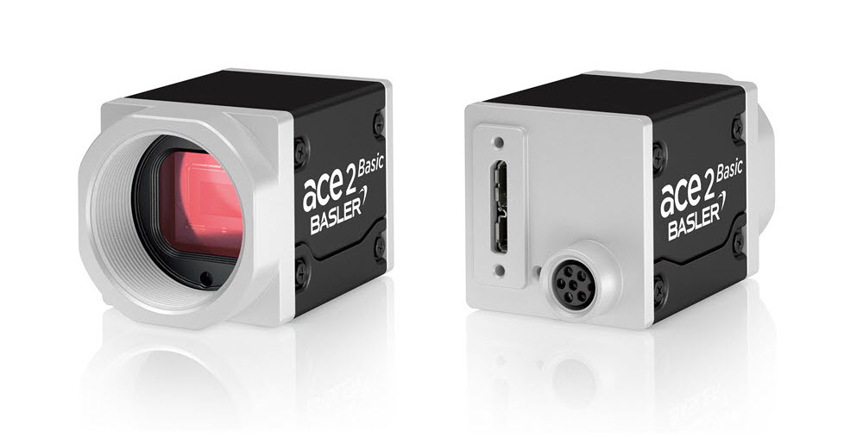

**Specifications**

**General Specifications**

|  | a2A3840-45ucBAS |
| --- | --- |
| Resolution (H x V Pixels) | 3860 x 2178 (full resolution) 3840 x 2160 (default resolution) |
| Resolution | 8.3 MP |
| Sensor Type | Sony IMX334LLR-C Progressive scan CMOS Rolling shutter |
| Sensor Format | 1/1.8" |
| Effective Sensor Diagonal | 8.86 mm |
| Pixel Size (H x V) | 2.0 x 2.0 µm |
| Frame Rate (at Default Settings) | 43.3 fps 45.7 fps (Device Link Throughput Limit mode set to Off) 24.3 fps (with triggering via Frame Start trigger) |
| Product Family | ace 2 R |
| Mono / Color | Colour |
| Image Data Interface | USB 3.0, nominal max. 5 Gbit/s (SuperSpeed) |
| Pixel Formats | See Pixel Format. |
| Synchronization | Via hardware trigger Via software trigger Via free run |
| Exposure Time Control | Programmable via the camera API |
| Camera Power Requirements | ≈2.5 W (typical) @ 5 VDC |
| I/O Lines | 1 opto-coupled input line 2 general purpose I/O (GPIO) lines |
| Lens Mount | C-mount |
| Size (L x W x H) | 36.3 x 29 x 29 mm (without lens mount or connectors) 48.1 x 29 x 29 mm (with lens mount and connectors) |
| Weight | <85 g |
| Conformity | CE (includes RoHS), EAC, UL Listed, FCC, KC, GenICam, USB3 Vision, IP30 Certificates for your camera model For more information, see the Compliance section of the Basler website. |
| Software | Basler pylon Software Suite (version 6.0 or higher) Available for Windows, Linux x86, Linux ARM, macOS, and Android |
| Accessories | Lenses –  C125-0418-5M-P f4mm 2000034830  C125-0618-5M-P f6mm 2000034831  C125-0818-5M-P f8mm 2000034832  C125-1218-5M-P f12mm 2000034833  C125-1620-5M-P f16mm 2000034834  C125-2522-5M-P f25mm 2000034835  Cables –  USB Cable - with screwlock 2200000620  USB Cable - with screwlock 2200000621  USB Cable - without screwlock 2000035131  USB Cable - without screwlock 2000035315  M8, 5m, axial - Lighting Cable 2200000899 |

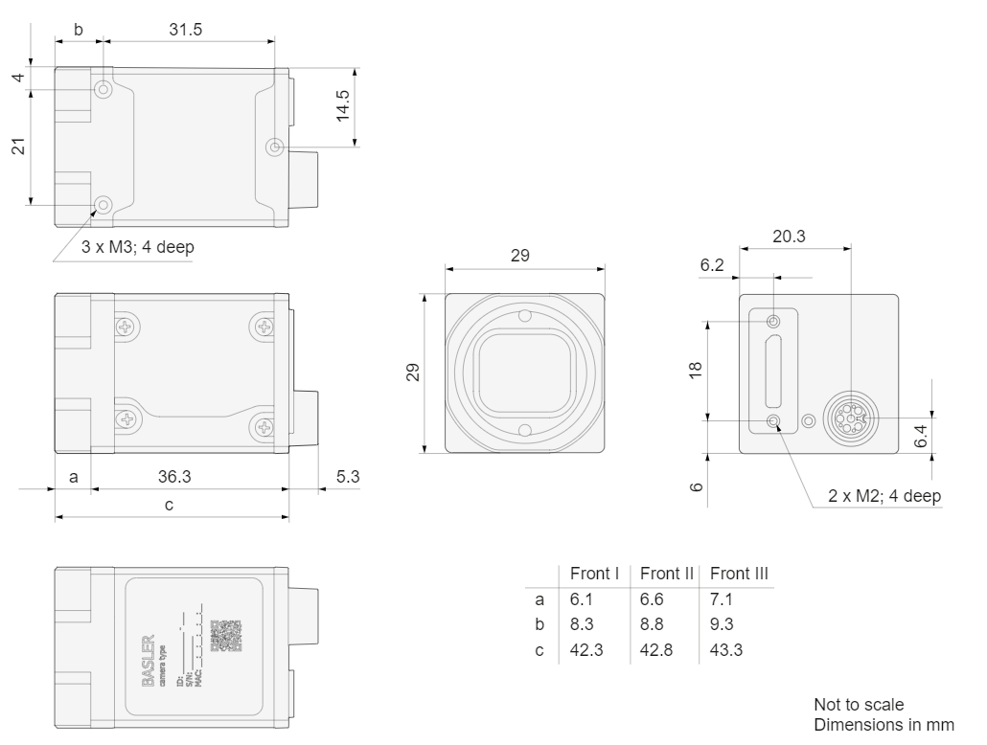Drawing –

