**a2A2840-67g5mUV**

The a2A2840-67g5mUV Basler ace 2 X camera is equipped with a Sony IMX487 sensor.

This ultraviolet (UV) camera with a 5GigE interface can capture images in the invisible light spectrum with wavelengths from 200–400 nm, the most suitable UV range for industrial inspections.

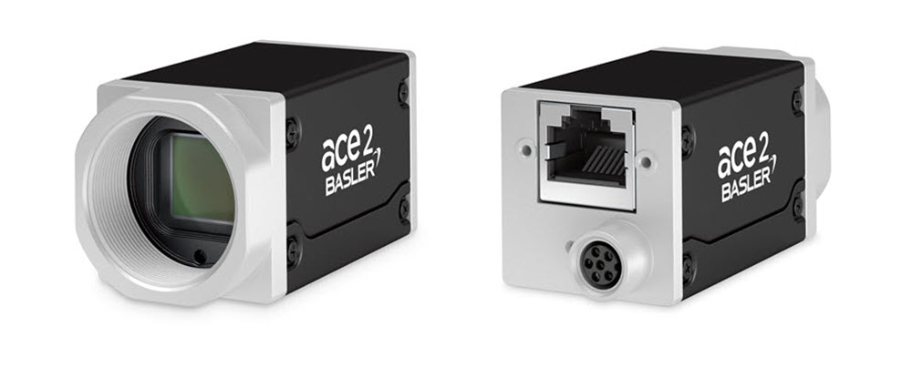

**Specifications**

**General Specifications**

|  | a2A2840-67g5mUV |
| --- | --- |
| Resolution (H x V Pixels) | 2856 x 2848 (full resolution) 2840 x 2840 (default resolution) |
| Resolution | 8 MP |
| Sensor Type | Sony IMX487-AAMJ-C Progressive scan CMOS Global shutter |
| Sensor Format | 2/3" |
| Effective Sensor Diagonal | 11.1 mm |
| Pixel Size (H x V) | 2.74 x 2.74 µm |
| Frame Rate (at Default Settings) | 66.5 fps 70.6 fps (with Bandwidth Reserve mode set to Performance and packet size set to 8192) |
| Product Family | ace 2 X |
| Mono / Color | Mono |
| Image Data Interface | Fast Ethernet (100 Mbit/s) Gigabit Ethernet (1000 Mbit/s) 2.5 Gigabit Ethernet (2500 Mbit/s) 5 Gigabit Ethernet (5000 Mbit/s) |
| Pixel Formats | See Pixel Format. |
| Synchronization | Via hardware trigger Via software trigger Via free run |
| Exposure Time Control | Via hardware trigger Programmable via the camera API |
| Camera Power Requirements | ≈5.3 W (typical) @ 12–24 VDC (supplied only via I/O connector) |
| I/O Lines | 1 opto-coupled input line 2 general purpose I/O (GPIO) lines |
| Lens Mount | C-mount |
| Size (L x W x H) | 48.9 x 29 x 29 mm (without lens mount or connectors) 62.2 x 29 x 29 mm (with lens mount and connectors) |
| Weight | <105 g |
| Conformity | CE (includes RoHS), EAC, UL (in preparation), FCC, KC, GenICam, GigE Vision, NBASE-T, IP30 Certificates for your camera model For more information, see the Compliance section of the Basler website. |
| Software | Basler pylon Software Suite (version 7.1 or higher) Available for Windows, Linux x86, and Linux ARM |

Accessories –

Lenses –

2200002148 AZURE-00202XZMUV-1 AZURE-00202XZMUV-1 UV Lens 25.0mm FL

2200002149 AZURE-00302XZMUV-1 AZURE-00302XZMUV-1 UV Lens 35mm FL

2200002150 AZURE-00503XZMUV-1 AZURE-00503XZMUV-1 UV Lens 50mmFL

2200002151 AZURE-00705XZMUV-1 AZURE-00705XZMUV-1 UV Lens 75mm FL

Cables –

USB Cable - with screwlock 2200000620

USB Cable - with screwlock 2200000621

USB Cable - without screwlock 2000035131

Drawing –

Please contact OEM Automatic for technical assistance.

Email: vision@oem.co.uk

Telephone: 01162849900