a2A2600-64umBAS
The a2A2600-64umBAS Basler ace 2 R camera is equipped with a Gpixel GMAX2505 sensor.
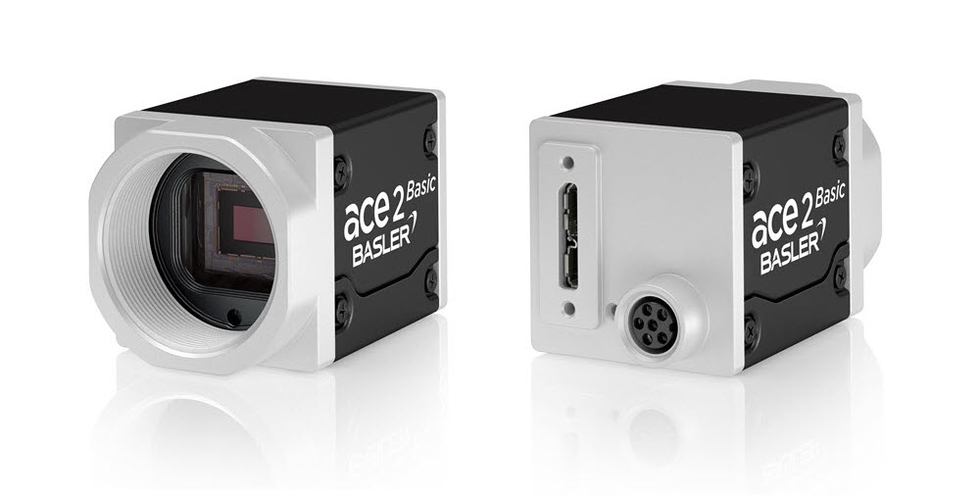
Specifications
General Specifications
 | a2A2600-64umBAS
Resolution (H x V Pixels) | 2600 x 2160 (full resolution)  2600 x 2128 (default resolution)
Resolution | 5 MP
Sensor Type | GMAX2505  Progressive scan CMOS  Global shutter
Sensor Format | 1/2"
Effective Sensor Diagonal | 8.45 mm
Pixel Size (H x V) | 2.5 x 2.5 µm
Frame Rate (at Default Settings) | 65.0 fps  70.4 fps (Device Link Throughput Limit mode set to Off)
Product Family | ace 2 R
Mono / Color | Mono
Image Data Interface | USB 3.0, nominal max. 5 Gbit/s (SuperSpeed)
Pixel Formats | See Pixel Format.
Synchronization | Via hardware trigger  Via software trigger  Via free run
Exposure Time Control | Via hardware trigger  Programmable via the camera API
Camera Power Requirements | ≈2.7 W (typical) @ 5 VDC
I/O Lines | 1 opto-coupled input line  2 general purpose I/O (GPIO) lines
Lens Mount | C-mount
Size (L x W x H) | 36.3 x 29 x 29 mm (without lens mount or connectors)  48.1 x 29 x 29 mm (with lens mount and connectors)
Weight | <85 g
Conformity | CE (includes RoHS), EAC, UL Listed, FCC, KC, GenICam, USB3 Vision, IP30  Certificates for your camera model  For more information, see the Compliance section of the Basler website.
Software | Basler pylon Software Suite (version 6.0 or higher)  Available for Windows, Linux x86, Linux ARM, macOS, and Android
Accessories | Lenses –  C125-0418-5M-P f4mm 2000034830  C125-0618-5M-P f6mm 2000034831  C125-0818-5M-P f8mm 2000034832  C125-1218-5M-P f12mm 2000034833  C125-1620-5M-P f16mm 2000034834  C125-2522-5M-P f25mm 2000034835  Cables –  USB Cable - with screwlock 2200000620  USB Cable - with screwlock 2200000621  USB Cable - without screwlock 2000035131  USB Cable - without screwlock 2000035315  M8, 5m, axial - Lighting Cable 2200000899
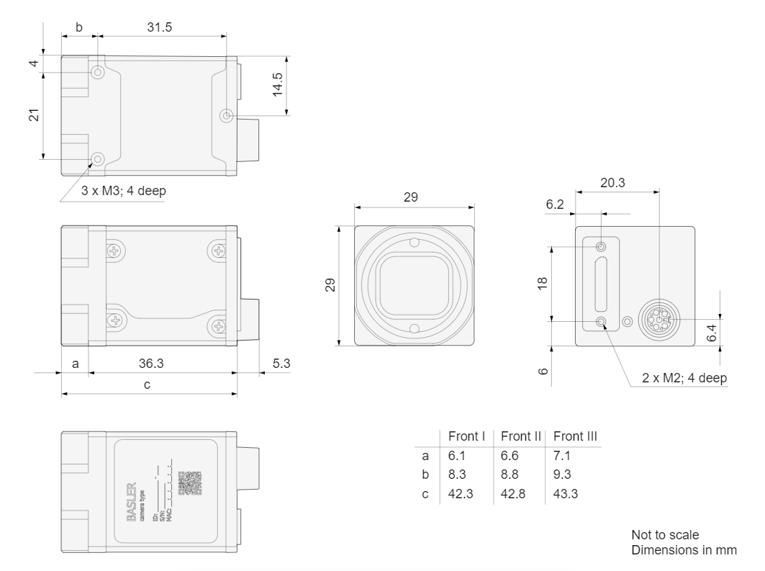
Drawing –


