**a2A1920-165g5cBAS**

The a2A1920-165g5mBAS Basler ace 2 5GigE camera is equipped with a Sony IMX392 sensor.

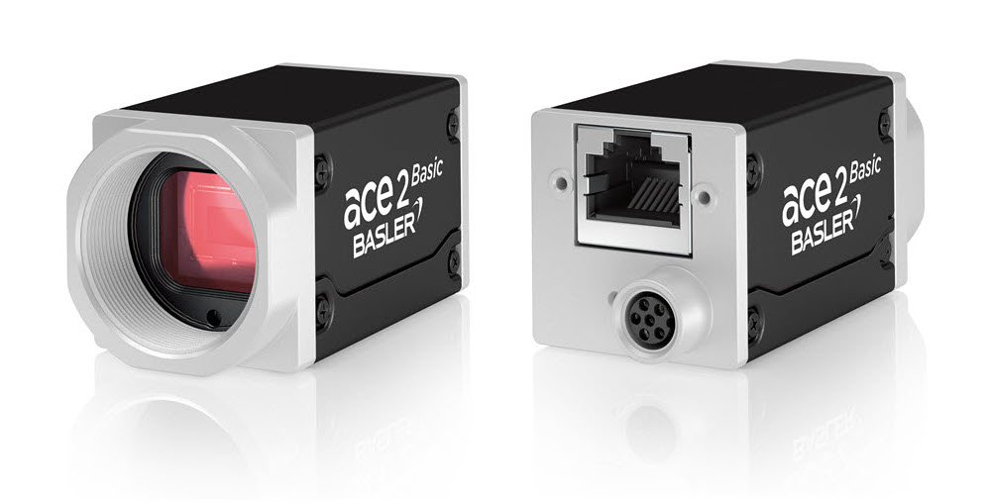

**Specifications**

**General Specifications**

|  | a2A1920-165g5cBAS |
| --- | --- |
| Resolution (H x V Pixels) | 1936 x 1216 (full resolution) 1920 x 1200 (default resolution) |
| Resolution | 2.3 MP |
| Sensor Type | Sony IMX392LQR-C Progressive scan CMOS Global shutter |
| Sensor Format | 1/2.3" |
| Effective Sensor Diagonal | 7.9 mm |
| Pixel Size (H x V) | 3.45 µm x 3.45 µm |
| Frame Rate (at Default Settings) | 168 fps |
| Product Family | ace 2 R |
| Mono / Color | Colour |
| Image Data Interface | Fast Ethernet (100 Mbit/s) Gigabit Ethernet (1000 Mbit/s) 2.5 Gigabit Ethernet (2500 Mbit/s) 5 Gigabit Ethernet (5000 Mbit/s) |
| Pixel Formats | See Pixel Format. |
| Synchronization | Via hardware trigger Via software trigger Via free run |
| Exposure Time Control | Via hardware trigger Programmable via the camera API |
| Camera Power Requirements | ≈5.3 W (typical) @ 12–24 VDC (supplied only via I/O connector) |
| I/O Lines | 1 opto-coupled input line 2 general purpose I/O (GPIO) lines |
| Lens Mount | C-mount |
| Size (L x W x H) | 48.9 mm x 29 mm x 29 mm (without lens mount or connectors) 62.2 mm x 29 mm x 29 mm (with lens mount and connectors) |
| Weight | <105 g |
| Conformity | CE (includes RoHS), EAC, UL Listed, FCC, KC, GenICam, GigE Vision, NBASE-T, IP30 Certificates for your camera model For more information, see the Compliance section of the Basler website. |
| Software | Basler pylon Software Suite (version 6.0 or higher) Available for Windows, Linux x86, Linux ARM, macOS, and Android |
| Accessories | Lenses –  C125-0418-5M-P f4mm 2000034830  C125-0618-5M-P f6mm 2000034831  C125-0818-5M-P f8mm 2000034832  C125-1218-5M-P f12mm 2000034833  C125-1620-5M-P f16mm 2000034834  C125-2522-5M-P f25mm 2000034835  Cables –  GigE Cable - with screwlock 2200000622  M8, 5m, axial - Lighting Cable 2200000899 |

Drawing –

Please contact OEM Automatic for technical assistance.

Email: [vision@oem.co.uk](mailto:vision@oem.co.uk)

Telephone: 01162849900