a2A1920-160umBAS
The a2A1920-160umBAS Basler ace 2 R camera is equipped with a Sony IMX392 sensor.
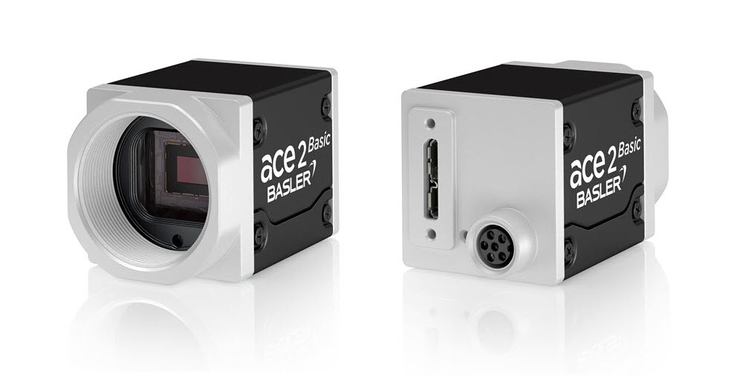
General Specifications
 | a2A1920-160umBAS
Resolution (H x V Pixels) | 1936 x 1216 (full resolution)  1920 x 1200 (default resolution)
Resolution | 2.3 MP
Sensor Type | Sony IMX392LLR-C  Progressive scan CMOS  Global shutter
Sensor Format | 1/2.3"
Effective Sensor Diagonal | 7.9 mm
Pixel Size (H x V) | 3.45 x 3.45 µm
Frame Rate (at Default Settings) | 164 fps
Product Family | ace 2 R
Mono / Color | Colour
Image Data Interface | USB 3.0, nominal max. 5 Gbit/s (SuperSpeed)
Pixel Formats | See Pixel Format.
Synchronization | Via hardware trigger  Via software trigger  Via free run
Exposure Time Control | Via hardware trigger  Programmable via the camera API
Camera Power Requirements | ≈2.8 W (typical) @ 5 VDC
I/O Lines | 1 opto-coupled input line  2 general purpose I/O (GPIO) lines
Lens Mount | C-mount
Size (L x W x H) | 36.3 x 29 x 29 mm (without lens mount or connectors)  48.1 x 29 x 29 mm (with lens mount and connectors)
Weight | <85 g
Conformity | CE (includes RoHS), EAC, UL Listed, FCC, KC, GenICam, USB3 Vision, IP30  Certificates for your camera model  For more information, see the Compliance section of the Basler website.
Software | Basler pylon Software Suite (version 6.0 or higher)  Available for Windows, Linux x86, Linux ARM, macOS, and Android
Accessories | Lenses –  C125-0418-5M-P f4mm 2000034830  C125-0618-5M-P f6mm 2000034831  C125-0818-5M-P f8mm 2000034832  C125-1218-5M-P f12mm 2000034833  C125-1620-5M-P f16mm 2000034834  C125-2522-5M-P f25mm 2000034835  Cables –  USB Cable - with screwlock 2200000620  USB Cable - with screwlock 2200000621  USB Cable - without screwlock 2000035131  USB Cable - without screwlock 2000035315  M8, 5m, axial - Lighting Cable 2200000899
Drawing:

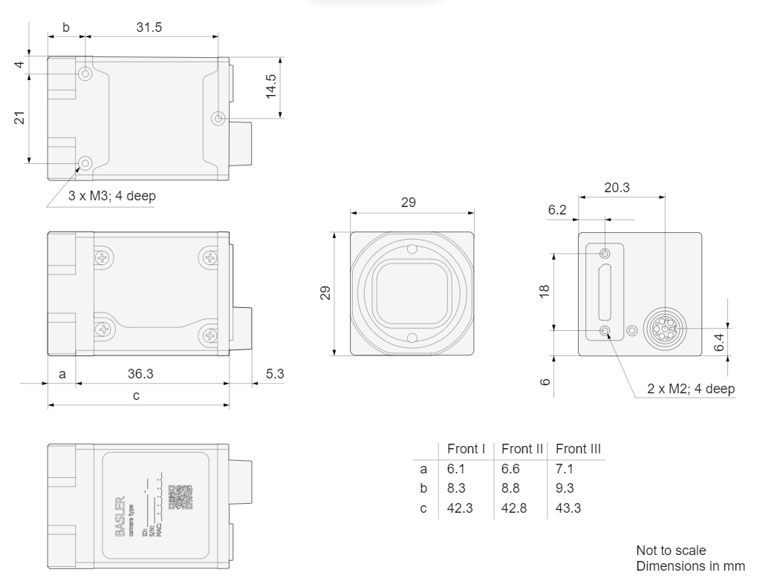

Please contact OEM Automatic for technical assistance.
Email: vision@oem.co.uk
Telephone: 01162849900

