Basler Light Controller 4C-1.25A-84W-24V - 2200001192
The Basler Light Controller 4C-1.25A-84W-24V allows you to use any Basler Standard Light as well as any other light device in your environment.
If you directly connect the lights to the controller, you can specify the output current supplied to the light which in turn controls the brightness. Alternatively, you can use a camera as an external trigger source allowing you to turn the light on or off.

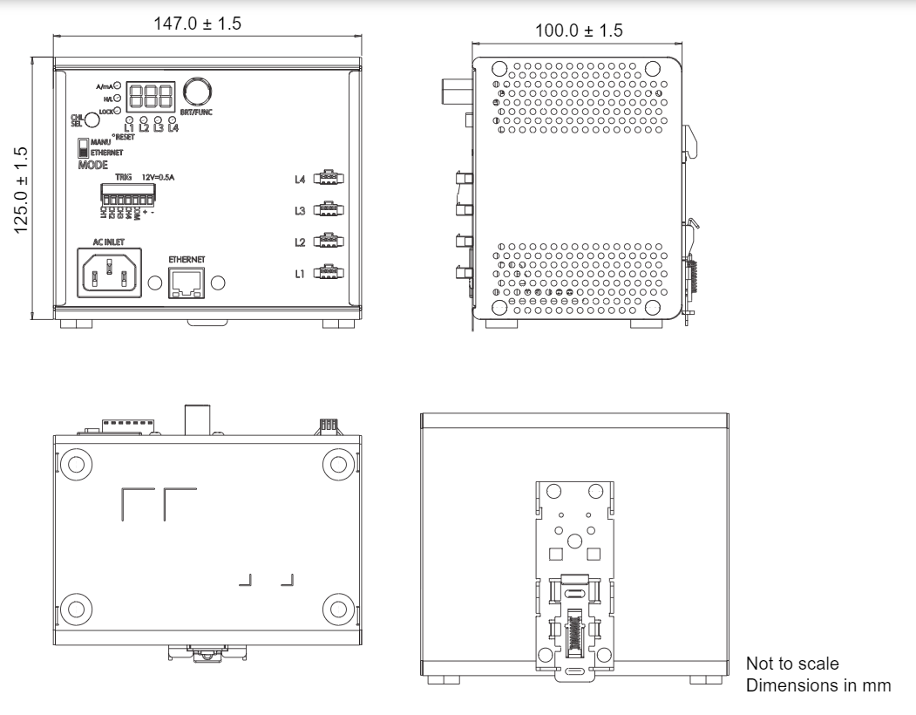

Specifications
General Specifications
 | Basler Light Controller 4C-1.25A-84W-24V
Input Voltage | 100–240 VAC
Power Consumption | 120 W (typically)
Driver Method | Constant-current system
Brightness Control Method | Manual (10 mA – 1.25 A) or via current limit
Communication Port | 100/10 Mbps Ethernet (TCP/UDP IP)
Number of Channels | 4
External Trigger Response | <50 µs
Protection | Short circuit protection  Over temperature protection  Current limit circuit
Channel 1–4 Output Voltage (Rate) | 8–24 VDC
Channel 1–4 Maximum Output Current (per Channel) | 1.25 A
12 V Output Voltage (Rate) | 12 VDC
12 V Maximum Output Current | 0.5 A
Max. Output Power | 30 W per channel; 84 W total (incl. channel 1–4 and 12 VDC Output)
Ripple Current | <15 % @ 24 VDC/1.25 A
External Trigger Input | 12–24 VDC; External On/Off trigger with High/Low active select
Size (L x W x H) | 147 x 100 x 129 mm
Weight | 1000 g (max.)
Connectors | 4 x 3-pin JST-SMR female connector (light)  7-pin PCB terminal block connector (trigger input)  RJ45 Ethernet connector  3-pin C14 connector (power input)
Conformity | CE (includes RoHS), UKCA, FCC, KC, REACH, PSE
Package Contents | Basler Light Controller 4C-1.25A-84W-24V  DIN rail bracket and screw (2200001191)  7-pin DC trigger connector (2200001264)
Accessories | AC power supply cable  Basler Standard Lights

