**Basler Standard Light Bar-45x100-x#**

Basler Standard Wide Bar Lights can be used in the same applications as Basler Standard Bar Lights but can illuminate larger objects due to a larger luminous area.

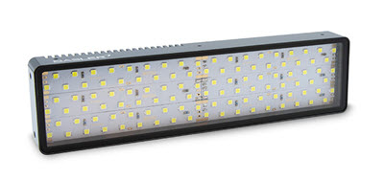

**Key Features#**

* Internal LED controller with 2 operating modes
* Compatible with Basler SLP Strobe Controller
* Preconfigured hardware components
* Various sizes and LED colors

**General Specifications**

|  |  | | Basler Standard Light Bar-45x100-White |
| --- | --- | --- | --- |
| Order Number |  | | 2200001112 |
| LED Color |  | | White |
| Luminous Area |  | | 45 x 100 mm |
| Recommended Light Working Distance | 10–300 mm | | 10–300 mm |
|  | |
| Conformity | |

**LED Specifications**

|  | Bar Light Series 45x100-x |
| --- | --- |
| Luminous Power of White LEDs (lumen) | 1380 |
| Radiant Power of Red LEDs (mW) | 4060 |
| Radiant Power of IR LEDs (mW) | 1950 |

**Electrical Specifications**

|  | Bar Light Series 45x100-x |
| --- | --- |
| Required Power for Voltage Control Mode | 24 VDC ± 5 %, 8 W |
| Required Current for Current Control Mode | Red, White, and Blue: 450 mA Infrared: 600 mA |
| Recommended max. LED Current for Strobe Mode (50 % Duty Cycle, 100 ms Pulses) | Red, White, and Blue: 900 mA Infrared: Must never be used. |
| Recommended max. LED Current for Strobe Mode (25 % Duty Cycle, 20 ms Pulses) | Red, White, and Blue: 1350 mA Infrared: Must never be used. |
| Recommended max. LED Current for Strobe Mode (10 % Duty Cycle, 5 ms Pulses) | Red, White, and Blue: 1800 mA Infrared: 1200 mA |
| Infrared only: Recommended max. LED Current for Strobe Mode (1 % Duty Cycle, 100 µs Pulses) | 1800 mA |
| Recommended min. Flash Time in Strobe Mode | 100 µs |

**Mechanical Specifications#**

|  | Bar Light Series 45x100-x |
| --- | --- |
| Dimensions (H x W x D) | 54 x 110 x 23 mm |
| Weight | 200 g |
| Material | Black anodized aluminum housing with PMMA light cover |
| Connector | M8 socket, 4-pin male connector |

Drawing:

