**Basler Cable USB 3.0, Micro B sl/A, S**[**#**](https://docs.baslerweb.com/basler-cable-usb3-microb-sl-a-s#basler-cable-usb-30-micro-b-sla-s)

USB 3.0 cable for data transmission with type A plug to Micro-B plug.

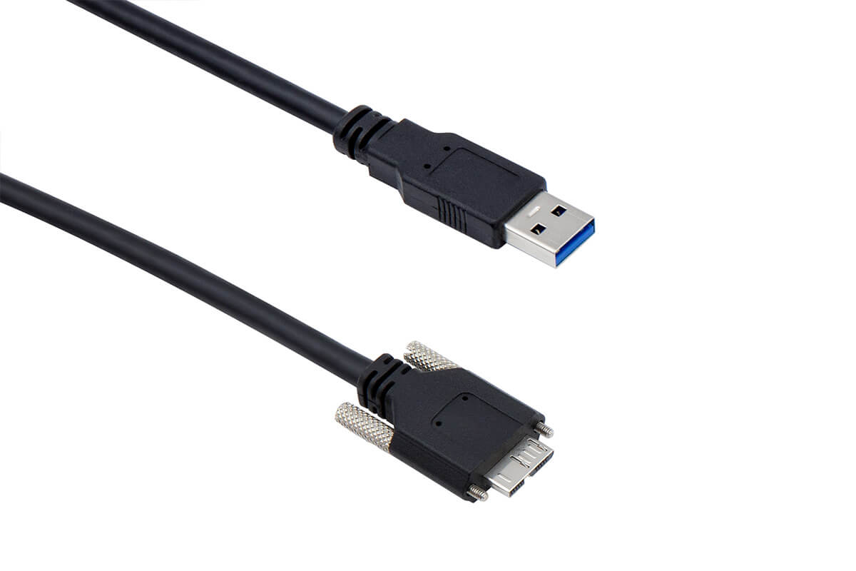

**Info**

The cable is suitable for ace and ace 2 cameras.

| Order Number | Cable Length |
| --- | --- |
| 2200000620 | 1 m |
| 2200000621 | 3 m |

**Cable Drawing**[**#**](https://docs.baslerweb.com/basler-cable-usb3-microb-sl-a-s#cable-drawing)

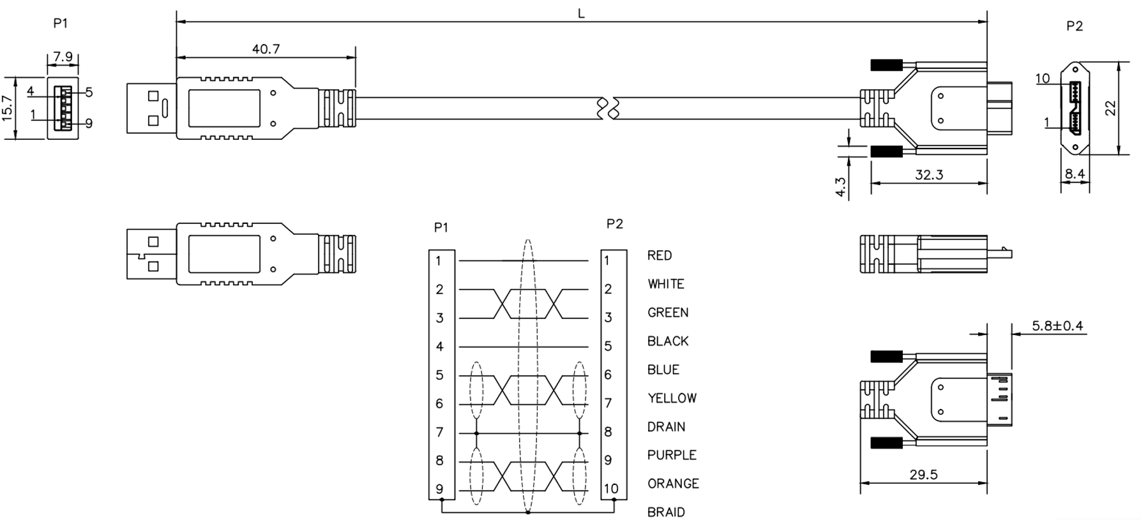

**Transfer Rates**[**#**](https://docs.baslerweb.com/basler-cable-usb3-microb-sl-a-s#transfer-rates)

|  | 2200000620 / 2200000621 |
| --- | --- |
| USB 2.0 | 480 Mbps |
| USB 3.0 | 5 Gbps |

**Physical Specifications**[**#**](https://docs.baslerweb.com/basler-cable-usb3-microb-sl-a-s#physical-specifications)

|  | 2200000620 / 2200000621 |
| --- | --- |
| Camera-Side Connector | Micro-B with screw lock |
| Host-Side Connector | Type A, USB-IF-compliant |
| Cable Diameter | 5.7 mm max. |
| Minimum Bending Radius | 28 mm, fixed installation |
| Maximum Bending Cycles | None (fixed installation only) |
| Suitable for Drag Chain Applications | No |
| Suitable for Robotics Applications | No |