Cable GigE M12, M, 8P/RJ45#
GigE cable for data transmission with an M12 8-pin connector on the camera side and RJ-45 plug on the host side.
Order Number | Cable Length
2200000614 | 2 m
2200000284 | 10 m
Cable Drawing
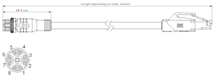

Physical Specifications
Camera-Side Connector | M12 8-pin, male plug, X standard coding (IEC 61076-2-109)
Host-Side Connector | RJ45
Cable Diameter | 6.4 mm
Outer Jacket | Black PVC
Minimum Bending Radius | 10 x cable diameter, fixed installation
Maximum Bending Cycles | None (fixed installation only)
Suitable for Drag Chain Applications | No
Suitable for Robotics Applications | No
Plug Specification#
Protection Rating | IP67 in locked position

